Com Ports For Go Crazy bot:

Ports will have to be manually set up in the control panel. As the peripherals connected will be converted to USB controller will only show very limited information. Therefore peripherals should be connect one at a time stating with the MC and then manually adjusting the setting in control panel to suite.

Goto device manager

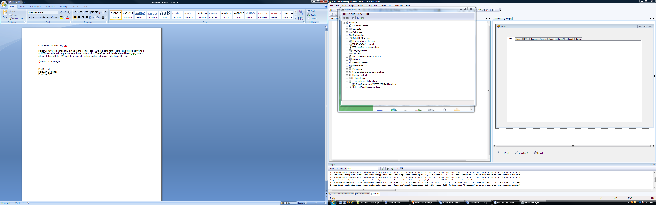

Select Universal Serial bus controllers:

Click on the USB to serial converter, select properties, change settings, advanced, then change port number to the required port.

Port 21= MC

Port 22= Compass

Port 23= GPS